1.Code:
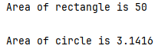
package origin;
class Shape {
public int l,w,R;
void calculatearea(){
}
}
class Rectangle extends Shape{
void calculatearea() {
System.out.println("Area of rectangle is "+(l*w)+"\n");
}
}
class Circle extends Shape{
void calculatearea() {
System.out.println("Area of circle is "+(3.1416*R*R)+"\n");
}
}
public class S{
public static void main(String[] args) {
Shape s=new Shape();
Rectangle r = new Rectangle();
r.l=10;
r.w=5;
Circle c = new Circle();
c.R=1;
s=r;
s.calculatearea();
s=c;
s.calculatearea();
}
}
Output:

2.Code:
package origin;
abstract class Payment{
public int balance=100;
abstract void processPayment();
void printreciept(){
System.out.println("Current Balance: "+balance+"\n");
}
}
class CreditCardPayment extends Payment{
void processPayment() {
System.out.println("Processing credit card payment...");
printreciept();
}
}
class MobileBankingPayment extends Payment{
void processPayment(){
System.out.println("Processing online banking payment...");
printreciept();
}
}
public class P {
public static void main(String[] args) {
CreditCardPayment c=new CreditCardPayment();
c.processPayment();
MobileBankingPayment m=new MobileBankingPayment();
m.processPayment();
}
}

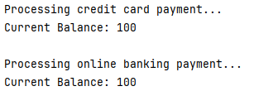
Output:

3.Code:
package origin;
interface Flyable{
void fly();
}
class Bird implements Flyable{
@Override
public void fly(){
System.out.println("Bird is flying\n");
}
}
class Airplane implements Flyable{
@Override
public void fly() {
System.out.println("Airplane is flying\n");
}
}
public class F {
public static void main(String[] args) {
Flyable f1=new Bird();
Flyable f2=new Airplane();
f1.fly();
f2.fly();
}
}
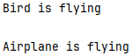
Output:

4.Code:
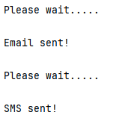
package origin;
interface Notification{
void sendMessage();
}
abstract class BaseNotification implements Notification{
public void sendMessage(){
System.out.println("Please wait.....\n");
}
}
class EmailNotification extends BaseNotification implements Notification{
public void sendMessage(){
super.sendMessage();
System.out.println("Email sent!\n");
}
}
class SMSNotification extends BaseNotification implements Notification{
public void sendMessage(){
super.sendMessage();
System.out.println("SMS sent!\n");
}
}
public class N {
public static void main(String[] args){
Notification n[]=new Notification[2];
n[0]=new EmailNotification();
n[1]=new SMSNotification();
n[0].sendMessage();
n[1].sendMessage();
}
}
Output:

